

**OCEANGATE PROJECT**

**Documentation**

**This is to certify that**

**Mr. M.Danish , A.Basit , Zeeshan , Ghulam Mustafa**

**Has successfully Designed & Developed**

**OceanGate Project**

**Submitted by: M.Danish**

**Date of Issue: 18-Apr-2014**

**ACKNOWLEDGEMENT**

I would like to acknowledge all those who have given me moral support and helped in making the project a success.

I wish to express my gratitude to eProject Team at Head Office who guided and helped me. Also, I would like to express my gratitude to all the staff members of my centre for not only providing me opportunity to work with them on this project, but also for their support and encouragement throughout the process.

I also express my sincere gratitude to eProject Team from Aptech Head Office and my project guide at the organization for his valuable guidance and support for completion of this project.

Final, I would like to offer many thanks to all my colleagues for their valuable suggestions and constructive feedback.

**TABLE OF CONTENT**

**Part 1: Project Brief .........................................................................** 1

I. PROBLEM DEFINITION ..................................................... 1

II. CUSTOMER REQUIREMENT SPECIFICATION ............. 2

III. SYSTEM STUDY ............................................................... 3

IV. PROJECT PLAN ................................................................. 4

1. Details ........................................................................... 4

2. Project Initiation/Requirement Document .................... 4

3. Deliverables .................................................................. 4

4. Quality Plan .................................................................. 5

5. SYSTEM REQUIREMENT……………….................. 5

**Part 2: Project Design** ......................................................................6

I. SITE MAP .............................................................................. 6

II. GUI DESIGN ........................................................................ 7

**Part 3: User Guide** .......................................................................... 14

I. SYSTEM REQUIREMENT……………………...…………14

II. INSTALL & RUN APPLICATION……………………….15

**Part4: Project Information**………………………………….…….17

TaskSheet................................................................................ 17

**Part5:** Appendix................................................................................19

**PART 1: PROJECT BRIEF 1**

1. **PROBLEM DEFINITION**

OceanGate Limited is a company established 3 years back which deals in various data storage products right from floppy disk to optical storage devices. It has state of the Art machinery for production of the storage devices/disks which are becoming popular as days pass by due to the excellent quality, fast delivery on purchases and efficient after sales Services.

Oceangate products have become so popular that the demand for the products is not only coming from local market but also international market.

**PART 1: PROJECT BRIEF 2**

**II.** **CUSTOMER SPECIFICATION**

1. The Home Page should be created making use of Frames with a suitable logo.
2. The site should display a menu which will contain the options for brief introduction about the various products available, location of the shop and any other information if required.
3. The information should be categorized according to the brand names of the products like if a User wants to see only Samsung products then he click on a Link/button/menu etc and he will see only That Brand products.
4. When a user selects any particular brand, a list of products for that brand will be displayed.
5. A brief summary of features of individual products should be displayed on the Web Page along with the product but detailed Features should be stored in Individual Word documents which can be downloaded or viewed by the User who wishes to see the same.
6. The user should also be able to compare the various products of different as well as similar brands.
7. There should be a “Contact Us” page which will have the Address of the Company which is as follows and the mail address which when clicked will invoke the local mail client from where they can send an email.

**PART 1: PROJECT BRIEF 3**

**III.** **SYSTEM STUDY**

1. List of Inputs to the system
   * Customer feedback: Full name, Telephone, Email ,Country,

Comment.

2. List of Outputs from the system

* + Product list: product type, product detail , categories, sample photographs, thumbnail form can click to a larger image, photo gallery.

3. Input Form

|  |  |  |
| --- | --- | --- |
| Form name | Description | Detail |
| Contacts  (Feed back) | This form is used for  customers’ comment ,  question and support. | Name , Email , Country and Comment are required. |

**PART 1: PROJECT BRIEF 4**

**IV. PROJECT PLAN**

1. Details

* + Name of the client: OceanGate
  + Date: 18-mar-2014
  + Project Objectives: Create a static website where people can easily view products , their details , compare products , map should be there , easy to navigate and the site must be responding for visitors’ good experience.
  + Scope: This project covers is to manage product information only, don’t support administration of dealers, customers. Other aspects such as late fine will not be covered.
* Our understanding of client organization: OceanGate Limited is a company which deals in various data storage products right from floppy disk to optical storage devices. Oceangate products have become so popular that the demand for the products is not only coming from local market but also international market.

2. Project Initiation / Requirement Document

* The form detail about products information
* The requirement specification documents of user’s functionalities

3. Deliverable

**PART 1: PROJECT BRIEF 5**

* The documents to be handed over to the client such as CRS, Design Document, User Manual.

4. Quality Plan

* Review Activities
* Testing Activities

**V.** **SYSTEM REQUIREMENT**

1. Software requirement

* A minimum computer system that will help you access all the tools in the courses is a Pentium 166 or better
* 64 Megabytes of RAM or better
* Windows 98 or higher

2. Hardware requirement

* Notepad/HTML editor
* Dreamweaver
* IE 5.0/ Netscape 6.0

**Part 2: Project Design 6**

1. **SITE MAP**

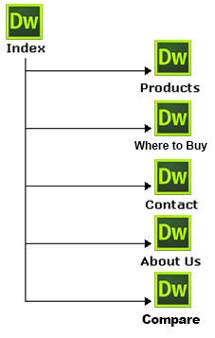

**Part 2: Project Design 7**

**II.** **GUI DESIGN**

**Index page:** This page serves as home page of the site where user is

introduced to the site it also categorizes all the functions of the site.

**Product page:** Shows product types and photo categories info.

**Where to Buy:** displays OceanGates’ seller’s shop near the visitors place.

**Contact page:** Contact information about OceanGate as address, telephone

number and mail-id

**About us page:** A brief introduction about OceanGate is

included on the page.

**Compare:** Here visitors can find a better and suitable products according to their need by comparing products of similar and different brands.

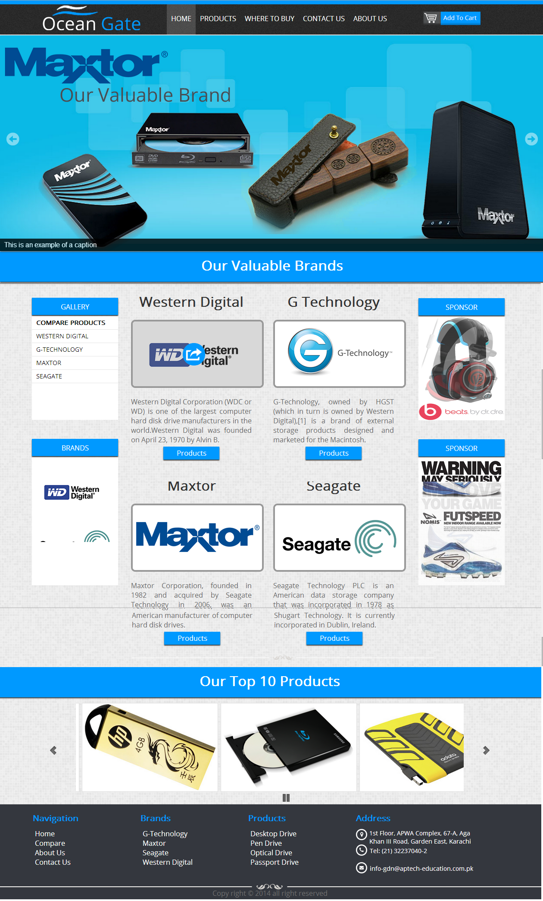**Part 2: Project Design 8**

**Index**

**Part 2: Project Design 9**

**Products**

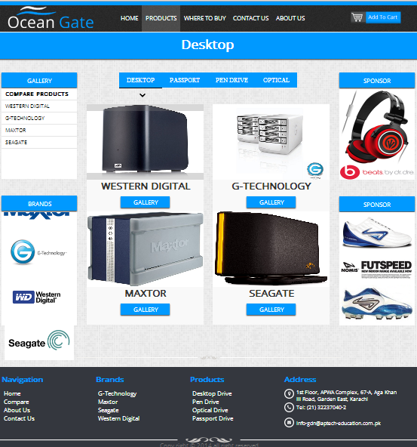

**Part 2: Project Design 10**

**Where to Buy**

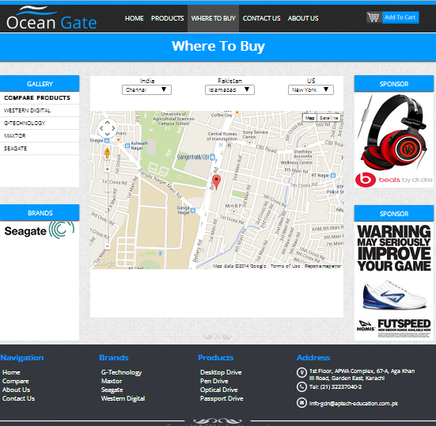

**Part 2: Project Design 11**

**Contact Us**

**Part 2: Project Design 12**

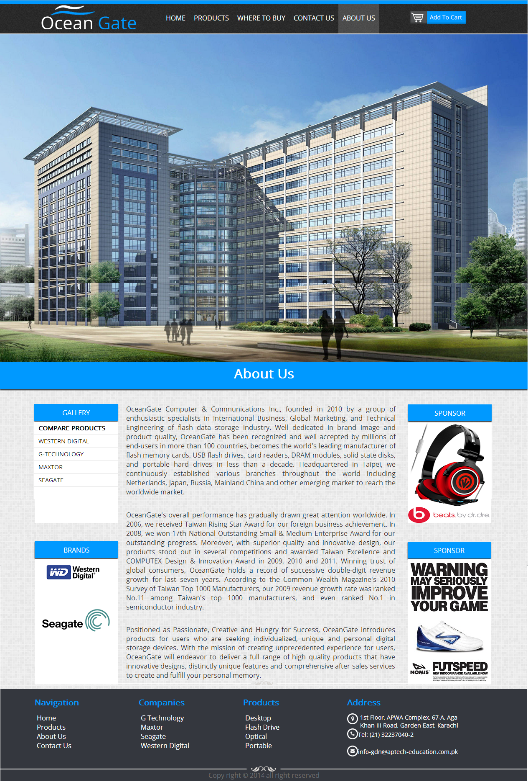**About Us**

**Part 2: Project Design 13**

**Compare Products**

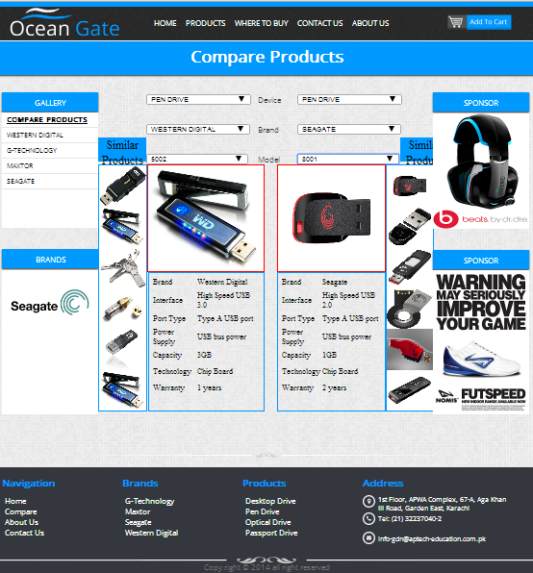

**PART 3: USER GUIDE 14**

1. **System Requirement**

|  |  |  |
| --- | --- | --- |
| No | Items | Description |
| 1 | Operating System | Windows 98, 2000, XP, or higher |
| 2 | Web Browser | Modern Browser i.e Chrome , Mozilla ,Opera , Safari |
| 3 | Software | Dreamweaver / FrontPage /Notepad++ |
| 4 | Zoom out capability | Upto 50% |
| 5 | Screen resolution  (best view) | 1136 x 640 or more |
| 6 | Responsive | No |

**PART 3: USER GUIDE 15**

**B.** **Install and Run Application**

**Step 1:** Copy folder Robin into “C:\”

**Step 2:** Open Dreamweaver

**Step 3:** Configure Site again

- Select Site, New Site

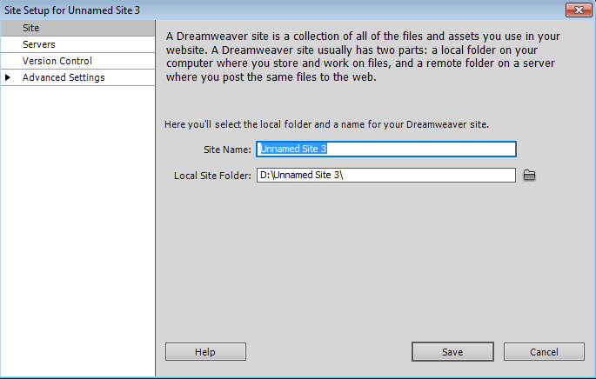

**PART 3: USER GUIDE 16**

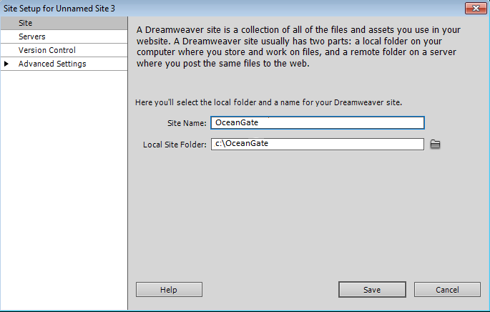

Site Name : OceanGate

Local Site Folder : c:\OceanGate

as demonstrated in above example

Then save it.

**Step 4:** To run application, Select index.html page to run or Open any Modern

Browser, after Enter: C:/OceanGate/index.html

**Part4: Project Information 17**

**TASK SHEET**

**Team: 1**

|  |  |  |
| --- | --- | --- |
| **Student No.** | **Student Name** | **Role** |
| 776126 | M.Danish | Leader |
| 773098 | A.Basit | Member |
| 773694 | Zeeshan | Member |
| 776129 | Ghulam | Member |

|  |  |  |  |  |  |  |  |
| --- | --- | --- | --- | --- | --- | --- | --- |
| Project Ref. No. | | Project  Title | Activity  Plan  Prepared  By: | Date of Preparation of Activity Plan | | | |
| Sr.  No | Task | Actual  Start  Date | Actual  Days | Team  Mate  Name | Status |
| 1 | Site  Design | OceanGate | M.Danish,  A.basit | Mar/18 | 5 | A.Basit | Completed |
| 2 | Collect  Info | OceanGate | M.Danish,  A.basit | Mar/18 | 3 | Zeeshan | Completed |
| 3 | Collect  Photo | OceanGate | M.Danish,  A.basit | Mar/22 | 5 | Zeeshan | Completed |
| 4 | Redesign  & Code | OceanGate | M.Danish,  A.basit | Mar/28 | 16 | M.Danish,  A.Basit | Completed |
| 5 | Draft  Document | OceanGate | M.Danish,  A.basit | Apr/17 | 1 | M.Danish,  A.Basit,  Zeeshan | Completed |
| 6 | Write  Document  Project | OceanGate | M.Danish,  A.basit | Apr/17 | 1 | M.Danish,  A.Basit,  Zeeshan | Completed |
| 7 | Review  Website | OceanGate | M.Danish | Apr/18 | 1 | M.Danish,  A.Basit,  Zeeshan | Completed |

**Part4: Project Information 18**

**CHECK LIST OF VALIDATIONS AND SUBMISSION CHECKLIST**

**CHECK LIST OF VALIDATION**

|  |  |
| --- | --- |
| Option | Validated |
| Fields in form should be not null | Done |
| Input mask are consistent | Yes |
| All page have forward link and to homepage | Yes |
| The site name for publishing is unique | Yes |

**SUBMISSION CHECKLIST**

|  |  |  |  |  |  |
| --- | --- | --- | --- | --- | --- |
| Sr. No. | Particulars | Yes | No | N/A | Comments |
| 1 | Do all the pages open | Yes |  |  |  |
| 2 | Are all hyperlinks working? | Yes |  |  |  |
| 3 | Are the web page contents  devoid of spelling mistakes | Yes |  |  |  |
| 4 | Are the page colour as per  common guidelines | Yes |  |  |  |
| 5 | Are all the web components  working? | Yes |  |  |  |
| 6 | Is site browser compatible? | Yes |  |  | Tested with Chrome , Mozilla , Opera and Safari |

**Part5:** **Appendix** **19**

**SOURCE CODE: jQuery to check a validating of Contact form**

**$('input , textarea').not('.submit').focus(function(){**

**$('#success').fadeOut(500);**

**$('#failed').fadeOut(500);**

**$(this).next('mark').fadeOut(500);**

**$(this).parent().find('strong').fadeOut(500,function(){**

**$(this).remove();**

**});**

**});**

**$('input , textarea').not('.ph , .submit ,.t2').blur(function(){**

**var empty = $(this).val();**

**var elem_class = $(this).attr('class');**

**if(elem_class =='t1' || 't3' || 't4'){**

**if($.trim(empty).length==0){**

**$(this).next('mark').fadeIn(500);**

**}else {**

**$("<strong ></strong>").appendTo($(this).parent('div')).css('display','none').fadeIn(500);**

**}**

**}**

**});**

**$('.t2').blur(function(){**

**var empty = $(this).val();**

**patt =/^[A-Za-z0-9._-]{1,20}@[A-Za-z]{1,6}\.[A-Za-z]{1,6}$/;**

**mail = patt.test(empty);**

**if(mail == false){**

**$(this).next('mark').fadeIn(500);**

**}else if (mail== true){**

**$("<strong ></strong>").appendTo($(this).parent('div')).css('display','none').fadeIn(500);**

**}**

**});**

**function vald(){**

**strong_elem = $('form').find('strong').length;**

**if(strong_elem == 4){**

**$('#success').fadeIn(1000);**

**}else{**

**$('#failed').fadeIn(1000);**

**}**

**}**

**SOURCE CODE: jQuery of changing brand pix**

**$(document).ready(function(){**

**$('#company_name li').click(function(){**

**$('#company_name li').css('border-style','none'); // border none**

**$('#company_name strong').css('display','none'); //all arrow pic vanish**

**$(this).find('strong').css('display','block'); //arrow pic displayed on clicked li**

**var comp_name = $(this).attr('data-info'); //getting stored value from data attribute of clicked li**

**$(this).css('border-bottom','2px solid black'); //border applied on clicked li**

**$('.max_h_t , .sea_h_t , .g_h_t , .wd_h_t').css('display','none'); // all testimonial vanish**

**$('.'+comp_name+'_h_t').css('display','block'); // testimonial displayed of specific brand**

**$('.max , .sea , .g , .wd').css('display','none'); // all brand pic vanish**

**$('.'+comp_name).css('display','block'); // specific brand displayed**

**});**

**});**

**SOURCE CODE: jQuery of left side drop down navigation**

$('pre').mousedown(function(){

state = $(this).siblings('ul').css('height');

if(state == '0px'){

$('#side_nav li').css('font-weight','normal');

$('#side_nav strong').css("background-image","url('images/arrow1.png')").css('display','none');

$('#side_nav >ul >li').css('background','white');

$('#side_nav >ul >li ul').css('height','0px');

$(this).siblings('strong').css("background-image","url('images/dwn-arrow1.png')").css('display','block');

$(this).parent('li').css('background','#09F')

.css('font-weight','bold')

$(this).parent('li').find('li').css('font-weight','normal');

$(this).siblings('ul').css('height','90px');

}else{

//$('#side_nav >ul >li ul').css('height','0px');

$(this).siblings('strong').css("background-image","url('images/arrow1.png')").css('display','none');

$(this).parent('li').css('background','white').css('font-weight','normal');

$(this).siblings('ul').css('height','0px');

$('#side_nav strong').mouseleave(function(){

$(this).css('display','none');

})

}

});

$('#side_nav >ul >li').hover(function(){

$(this).children('strong').css('display','block');

},function(){

asd=$(this).children('ul').css('height');

$(this).children('strong').css('display','none');

if(asd != '0px'){

$(this).children('strong').css('display','block');

}

});

**SOURCE CODE**

**jQuery of map**

<script src="http://maps.google.com/maps/api/js?sensor=false">

</script>

<script>

$(document).ready(function(){

lng_lat= new Array();

lng_lat[0]=13.024312;

lng_lat[1]=77.585205;

// google api

function showMap() {

var location= new Array(2);

location[0]=new Array('name',lng_lat[0],lng_lat[1]);

//location[0]=new Array('pakistan',24.893379,67.02816);

//location[1]=new Array('india',20.593684,78.96288);

var mapOptions={

zoom: 16,

center: new google.maps.LatLng(lng_lat[0],lng_lat[1]),

mapTypeId: google.maps.MapTypeId.ROADMAP

};

var map= new google.maps.Map(document.getElementById('map'),mapOptions);

var marker,i;

marker= new google.maps.Marker(

{

animation: google.maps.Animation.DROP,

position: new google.maps.LatLng(location[0][1],location[0][2]),

map:map

});

}

showMap();

$('article select').change(function(){

aaa=$(this).data('info'); //getting value of data attribute

var city=$(this).val(); //getting map long lat value stored in option element

var long_lat = city.split(','); // separate long value and latitude value

lng_lat[0] =long_lat[0]; //giving longitude value

lng_lat[1] =long_lat[1]; //giving latitude value

showMap(); //running map api

})

});

$('select').change(function(){

$('section div').not('#map').css('display','none'); // vanishing all div containing information(contact, email, address)

asd=$(this).find('option:selected').attr('data-info'); // getting selected class of div to display information

$(asd).css('display','block'); //display selected class of div and the element inside

$(asd+' div').eq(0).fadeTo(500,1);

$(asd+' div').eq(1).fadeTo(1000,1);

$(asd+' div').eq(2).fadeTo(1500,1);

});

$('#pro >ul > li').hover(function(){

$('#menu >ul > li >ul').css('overflow','visible');

},function(){

$('#menu >ul > li >ul').css('overflow','hidden');

});

</script>

**SOURCE CODE: jQuery of cart effect animation**

**$(document).ready(function(){**

**loop = new Array(); // working click count**

**class_array = new Array(); // class of clicked anchor element**

**anchor_len = $('#product-gallery a').length //anchor length**

**img_id_list= new Array(); //img id**

**img_src_list= new Array(); //img src**

**for(var i=0; i<anchor_len; i++){**

**$('#product-gallery a').eq(i).attr('data-imgid','imgg'+i) //creating data attribute in anchor element**

**$('#product-gallery img').eq(i).attr('id','imgg'+i); //giving id (stored in anchor's data attr) to all img**

**}**

**$(document.body).on('click',('#header-inner #cart ul ul li strong'),function(){**

**x_class = $(this).data('class'); // getting value of data attr(of anchor) stored in strong element**

**x_imgid = $(this).data('imgid'); // getting value of data attr stored in strong element**

**$('.'+x_class).removeAttr('data-cart'); // removing data attribute of anchor element of specified class**

**$('.'+x_class).find('div').css('background','#09f'); // change background of parent of specified class**

**$('#'+x_imgid).parent().removeClass('filter_brightness'); //removing class**

**$(this).parent().remove(); //removing element**

**count--; // decreasing counting by 1**

**for(var mm = 0; mm<loop.length ; mm++){**

**$('#header-inner #cart span').eq(mm).html(counting[mm]); //restart counting**

**}**

**loop.splice(0,1); //removing 1 value from array**

**if(loop.length == 0){**

**$('#header-inner #cart ul ul ').append('<li>empty</li>')**

**}**

**});**

**count = 0;**

**$('.gallery a').click(function(){**

**count++;**

**if($(this).attr('data-cart')){ // if data-cart attribute exist**

**count--;**

**}else{ // if not**

**cart_pos = $('#header-inner #cart').offset(); // getting position of cart**

**cart_top = cart_pos.top; // getting top value of cart**

**cart_left= cart_pos.left; // getting left value of cart**

**event=event||window.event, // position of clicked area in document**

**x=event.pageX||event.clientX+document.body.scrollLeft,**

**y=event.pageY||event.clientY+document.body.scrollTop;**

**img_src=$(this).parent('center').siblings('img').attr('src'); // getting img src related to clicked anchor**

**$("<img style='width:100px; height:100px' class='new_pic' src='"+ img_src +"' />").css('opacity','0.6').css('left',x).css('top',(y-250)).appendTo('#main').animate({left: cart_left, top: cart_top},800,function(){**

**$('.new_pic').remove(); // animate the pic then remove**

**});**

**$(this).attr('data-cart', count); //giving value to anchor's data cart attribute**

**$(this).attr('class','cart'+count); //giving specific class to anchor element**

**img_id = $(this).data('imgid'); //getting value of data attribute(which is the id of img) stored in anchor element**

**img_src = $('#'+img_id).attr('src'); //getting img src**

**img_id_list[count-1] = img_id;**

**img_src_list[count-1]=img_src;**

**class_array[count-1] = $(this).attr('class');**

**$('#'+img_id).parent().addClass('filter_brightness');**

**$(this).find('div').css('background','gray');**

**$('#header-inner #cart ul ul li').remove();**

**counting =['1st)','2nd)','3rd)','4th)','5th)','6th)']**

**loop[count-1]=count;**

**for( var i=0; i<loop.length; i++){ // cart li**

**$('#header-inner #cart ul ul ').append("<li><a target='_black' href='" + img_src_list[i] + "'><span>" + counting[i] + "</span> item added</a> <strong style='position:absolute;right:20px;' data-imgid='" +img_id_list[i]+ "' data-class='"+ class_array[i] +"' >x</strong></li>");**

**}**

**}**

**});**

**});**

**SOURCE CODE: jQuery of compare page**

**$(document).ready(function(){**

**make_id = ['temporary_value'];**

**index_of_model = ['1001','1002','1003','1004','1005','1006','2001','2002','2003','2004','2005','2006','3001','3002','3003','3004','3005','3006','4001','4002','4003','4004','4005','4006',**

**'5001','5002','5003','5004','5005','5006','6001','6002','6003','6004','6005','6006','7001','7002','7003','7004','7005','7006','8001','8002','8003','8004','8005','8006',**

**'9001','9002','9003','9004','9005','9006','1101','1102','1103','1104','1105','1106','1201','1202','1203','1204','1205','1206','1301','1302','1303','1304','1305','1306',**

**'1401','1402','1403','1404','1405','1406','1501','1502','1503','1504','1505','1506','1601','1602','1603','1604','1605','1606','1701','1702','1703','1704','1705','1706'**

**];**

**desktop_wd = ['---------------Model---------------','1001','1002','1003','1004','1005','1006'];**

**passport_wd = ['---------------Model---------------','9001','9002','9003','9004','9005','9006'];**

**pen_drive_wd = ['---------------Model---------------','5001','5002','5003','5004','5005','5006'];**

**optical_wd = ['---------------Model---------------','1401','1402','1403','1404','1405','1406'];**

**desktop_g = ['---------------Model---------------','4001','4002','4003','4004','4005','4006'];**

**passport_g = ['---------------Model---------------','1101','1102','1103','1104','1105','1106'];**

**pen_drive_g = ['---------------Model---------------','6001','6002','6003','6004','6005','6006'];**

**optical_g = ['---------------Model---------------','1501','1502','1503','1504','1505','1506'];**

**desktop_max = ['---------------Model---------------','2001','2002','2003','2004','2005','2006'];**

**passport_max = ['---------------Model---------------','1201','1202','1203','1204','1205','1206'];**

**pen_drive_max = ['---------------Model---------------','7001','7002','7003','7004','7005','7006'];**

**optical_max = ['---------------Model---------------','1601','1602','1603','1604','1605','1606'];**

**desktop_sea = ['---------------Model---------------','3001','3002','3003','3004','3005','3006'];**

**passport_sea = ['---------------Model---------------','1301','1302','1303','1304','1305','1306'];**

**pen_drive_sea = ['---------------Model---------------','8001','8002','8003','8004','8005','8006'];**

**optical_sea = ['---------------Model---------------','1701','1702','1703','1704','1705','1706'];**

**product_brand_index =['desktop_wd','passport_wd','pen_drive_wd','optical_wd','desktop_g','passport_g','pen_drive_g','optical_g','desktop_max','passport_max','pen_drive_max','optical_max','desktop_sea','passport_sea','pen_drive_sea','optical_sea'];**

**product_brand_val_index =[desktop_wd,passport_wd,pen_drive_wd,optical_wd,desktop_g,passport_g,pen_drive_g,optical_g,desktop_max,passport_max,pen_drive_max,optical_max,desktop_sea,passport_sea,pen_drive_sea,optical_sea];**

**des_of_prod =['<tr><td>Brand</td><td>Western Digital</td></tr><tr><td>Capacity</td><td>upto2TB</td></tr><tr><td>Interface</td><td>2xThunderbolt</td></tr><tr><td>HDD</td><td>7200RPM</td></tr><tr><td>Transfer Rate</td><td>256Mb/s</td></tr><tr><td>Price </td><td> $749.95</td></tr>',**

**'<tr><td>Brand</td><td>Western Digital</td></tr><tr><td>Capacity</td><td>upto 2TB</td></tr><tr><td>Interface</td><td>4xThunderbolt</td></tr><tr><td>HDD</td><td>8200RPM</td></tr><tr><td>Transfer Rate</td><td>356Mb/s</td></tr><tr><td>Price </td><td> $849.95</td></tr>',**

**'<tr><td>Brand</td><td>Western Digital</td></tr><tr><td>Capacity</td><td>upto 1TB</td></tr><tr><td>Interface</td><td> 2xThunderbolt</td></tr><tr><td>HDD</td><td>6200RPM</td></tr><tr><td>Transfer Rate</td><td>200Mb/s</td></tr><tr><td>Price</td><td> $649.95</td></tr>',**

**'<tr><td>Brand</td><td>Western Digital</td></tr><tr><td>Capacity</td><td>upto 3TB</td></tr><tr><td>Interface</td><td>2xThunderbolt</td></tr><tr><td>HDD</td><td>520RPM</td></tr><tr><td>Transfer Rate</td><td>250Mb/s</td></tr><tr><td>Price</td><td>$549.95</td></tr>',**

**'<tr><td>Brand</td><td>Western Digital</td></tr><tr><td>Capacity</td><td>upto 1TB</td></tr><tr><td>Interface </td><td> 1xThunderbolt</td></tr><tr><td>HDD</td><td>4200RPM</td></tr><tr><td>Transfer Rate</td><td>300Mb/s</td></tr><tr><td>Price</td><td>$449.95</td></tr>',**

**'<tr><td>Brand</td><td>Western Digital</td></tr><tr><td>Capacity</td><td>upto 1TB</td></tr><tr><td>Interface</td><td> 2xThunderbolt</td></tr><tr><td>HDD</td><td>6200RPM</td></tr><tr><td>Transfer Rate</td><td>200Mb/s</td></tr><tr><td>Price</td><td> $649.95</td></tr>',**

**'<tr><td>Brand</td><td>Maxtor</td></tr><tr><td>Capacity</td><td>upto2TB</td></tr><tr><td>Interface</td><td>2xThunderbolt</td></tr><tr><td>HDD</td><td>745RPM</td></tr><tr><td>Transfer Rate</td><td>234Mb/s</td></tr><tr><td>Price </td><td> $234.95</td></tr>',**

**'<tr><td>Brand</td><td>Maxtor</td></tr><tr><td>Capacity</td><td>upto 4TB</td></tr><tr><td>Interface</td><td>4xThunderbolt</td></tr><tr><td>HDD</td><td>3245RPM</td></tr><tr><td>Transfer Rate</td><td>345Mb/s</td></tr><tr><td>Price </td><td> $654.95</td></tr>',**

**'<tr><td>Brand</td><td>Maxtor</td></tr><tr><td>Capacity</td><td>upto 6TB</td></tr><tr><td>Interface</td><td> 2xThunderbolt</td></tr><tr><td>HDD</td><td>3242RPM</td></tr><tr><td>Transfer Rate</td><td>456Mb/s</td></tr><tr><td>Price</td><td> $324.95</td></tr>',**

**'<tr><td>Brand</td><td>Maxtor</td></tr><tr><td>Capacity</td><td>upto 8TB</td></tr><tr><td>Interface</td><td>2xThunderbolt</td></tr><tr><td>HDD</td><td>544PM</td></tr><tr><td>Transfer Rate</td><td>844Mb/s</td></tr><tr><td>Price</td><td>$733.95</td></tr>',**

**'<tr><td>Brand</td><td>Maxtor</td></tr><tr><td>Capacity</td><td>upto 9TB</td></tr><tr><td>Interface </td><td> 1xThunderbolt</td></tr><tr><td>HDD</td><td>754RPM</td></tr><tr><td>Transfer Rate</td><td>345Mb/s</td></tr><tr><td>Price</td><td>$733.95</td></tr>',**

**'<tr><td>Brand</td><td>Maxtor</td></tr><tr><td>Capacity</td><td>upto 7TB</td></tr><tr><td>Interface</td><td> 2xThunderbolt</td></tr><tr><td>HDD</td><td>6230RPM</td></tr><tr><td>Transfer Rate</td><td>734Mb/s</td></tr><tr><td>Price</td><td> $253.95</td></tr>',**

**'<tr><td>Brand</td><td>Seagate</td></tr><tr><td>Capacity</td><td>upto7TB</td></tr><tr><td>Interface</td><td>2xThunderbolt</td></tr><tr><td>HDD</td><td>7345RPM</td></tr><tr><td>Transfer Rate</td><td>2346Mb/s</td></tr><tr><td>Price </td><td> $357.95</td></tr>',**

**'<tr><td>Brand</td><td>Seagate</td></tr><tr><td>Capacity</td><td>upto 5TB</td></tr><tr><td>Interface</td><td>4xThunderbolt</td></tr><tr><td>HDD</td><td>6345RPM</td></tr><tr><td>Transfer Rate</td><td>956Mb/s</td></tr><tr><td>Price </td><td> $734.95</td></tr>',**

**'<tr><td>Brand</td><td>Seagate</td></tr><tr><td>Capacity</td><td>upto 4TB</td></tr><tr><td>Interface</td><td> 2xThunderbolt</td></tr><tr><td>HDD</td><td>2345RPM</td></tr><tr><td>Transfer Rate</td><td>700Mb/s</td></tr><tr><td>Price</td><td> $457.95</td></tr>',**

**'<tr><td>Brand</td><td>Seagate</td></tr><tr><td>Capacity</td><td>upto 2TB</td></tr><tr><td>Interface</td><td>2xThunderbolt</td></tr><tr><td>HDD</td><td>5345RPM</td></tr><tr><td>Transfer Rate</td><td>550Mb/s</td></tr><tr><td>Price</td><td>$875.95</td></tr>',**

**'<tr><td>Brand</td><td>Seagate</td></tr><tr><td>Capacity</td><td>upto 4TB</td></tr><tr><td>Interface </td><td> 1xThunderbolt</td></tr><tr><td>HDD</td><td>46435PM</td></tr><tr><td>Transfer Rate</td><td>300Mb/s</td></tr><tr><td>Price</td><td>$444.95</td></tr>',**

**'<tr><td>Brand</td><td>Seagate</td></tr><tr><td>Capacity</td><td>upto 9TB</td></tr><tr><td>Interface</td><td> 2xThunderbolt</td></tr><tr><td>HDD</td><td>6200RPM</td></tr><tr><td>Transfer Rate</td><td>100Mb/s</td></tr><tr><td>Price</td><td> $345.95</td></tr>',**

**'<tr><td>Brand</td><td>G-technology</td></tr><tr><td>Capacity</td><td>upto1TB</td></tr><tr><td>Interface</td><td>2xThunderbolt</td></tr><tr><td>HDD</td><td>7200RPM</td></tr><tr><td>Transfer Rate</td><td>256Mb/s</td></tr><tr><td>Price </td><td> $734.95</td></tr>',**

**'<tr><td>Brand</td><td>G-technology</td></tr><tr><td>Capacity</td><td>upto 3TB</td></tr><tr><td>Interface</td><td>4xThunderbolt</td></tr><tr><td>HDD</td><td>7345RPM</td></tr><tr><td>Transfer Rate</td><td>8006Mb/s</td></tr><tr><td>Price </td><td> $863.95</td></tr>',**

**'<tr><td>Brand</td><td>G-technology</td></tr><tr><td>Capacity</td><td>upto 5TB</td></tr><tr><td>Interface</td><td> 2xThunderbolt</td></tr><tr><td>HDD</td><td>435RPM</td></tr><tr><td>Transfer Rate</td><td>600Mb/s</td></tr><tr><td>Price</td><td> $235.95</td></tr>',**

**'<tr><td>Brand</td><td>G-technology</td></tr><tr><td>Capacity</td><td>upto 7TB</td></tr><tr><td>Interface</td><td>2xThunderbolt</td></tr><tr><td>HDD</td><td>734RPM</td></tr><tr><td>Transfer Rate</td><td>400Mb/s</td></tr><tr><td>Price</td><td>$343.95</td></tr>',**

**'<tr><td>Brand</td><td>G-technology</td></tr><tr><td>Capacity</td><td>upto 1TB</td></tr><tr><td>Interface </td><td> 1xThunderbolt</td></tr><tr><td>HDD</td><td>4634RPM</td></tr><tr><td>Transfer Rate</td><td>300Mb/s</td></tr><tr><td>Price</td><td>$345.95</td></tr>',**

**'<tr><td>Brand</td><td>G-technology</td></tr><tr><td>Capacity</td><td>upto 2TB</td></tr><tr><td>Interface</td><td> 2xThunderbolt</td></tr><tr><td>HDD</td><td>345RPM</td></tr><tr><td>Transfer Rate</td><td>200Mb/s</td></tr><tr><td>Price</td><td> $649.95</td></tr>',**

**'<tr><td>Brand</td><td>Western Digital</td></tr><tr><td>Interface </td><td>High Speed USB 2.0</td></tr><tr><td>Port Type</td><td>Type A USB port</td></tr><tr><td>Power Supply </td><td>USB bus power</td></tr><tr><td>Capacity</td><td>2GB</td></tr><tr><td>Technology</td><td>Chip Board</td></tr><tr><td>Warranty </td><td>2 years</td></tr>',**

**'<tr><td>Brand</td><td>Western Digital</td></tr><tr><td>Interface </td><td>High Speed USB 3.0</td></tr><tr><td>Port Type</td><td>Type A USB port</td></tr><tr><td>Power Supply </td><td>USB bus power</td></tr><tr><td>Capacity</td><td>3GB</td></tr><tr><td>Technology</td><td>Chip Board</td></tr><tr><td>Warranty </td><td>1 years</td></tr>',**

**'<tr><td>Brand</td><td>Western Digital</td></tr><tr><td>Interface </td><td>High Speed USB 2.0</td></tr><tr><td>Port Type</td><td>Type A USB port</td></tr><tr><td>Power Supply </td><td>USB bus power</td></tr><tr><td>Capacity</td><td>4GB</td></tr><tr><td>Technology</td><td>Chip Board</td></tr><tr><td>Warranty </td><td>2 years</td></tr>',**

**'<tr><td>Brand</td><td>Western Digital</td></tr><tr><td>Interface </td><td>High Speed USB 3.0</td></tr><tr><td>Port Type</td><td>Type A USB port</td></tr><tr><td>Power Supply </td><td>USB bus power</td></tr><tr><td>Capacity</td><td>5GB</td></tr><tr><td>Technology</td><td>Chip Board</td></tr><tr><td>Warranty </td><td>1 years</td></tr>',**

**'<tr><td>Brand</td><td>Western Digital</td></tr><tr><td>Interface </td><td>High Speed USB 2.0</td></tr><tr><td>Port Type</td><td>Type A USB port</td></tr><tr><td>Power Supply </td><td>USB bus power</td></tr><tr><td>Capacity</td><td>6GB</td></tr><tr><td>Technology</td><td>Chip Board</td></tr><tr><td>Warranty </td><td>2 years</td></tr>',**

**'<tr><td>Brand</td><td>Western Digital</td></tr><tr><td>Interface </td><td>High Speed USB 3.0</td></tr><tr><td>Port Type</td><td>Type A USB port</td></tr><tr><td>Power Supply </td><td>USB bus power</td></tr><tr><td>Capacity</td><td>7GB</td></tr><tr><td>Technology</td><td>Chip Board</td></tr><tr><td>Warranty </td><td>1 years</td></tr>',**

**'<tr><td>Brand</td><td>G-technolog</td></tr><tr><td>Interface </td><td>High Speed USB 3.0</td></tr><tr><td>Port Type</td><td>Type A USB port</td></tr><tr><td>Power Supply </td><td>USB bus power</td></tr><tr><td>Capacity</td><td>7GB</td></tr><tr><td>Technology</td><td>Chip Board</td></tr><tr><td>Warranty </td><td>1 years</td></tr>',**

**'<tr><td>Brand</td><td>G-technolog</td></tr><tr><td>Interface </td><td>High Speed USB 2.0</td></tr><tr><td>Port Type</td><td>Type A USB port</td></tr><tr><td>Power Supply </td><td>USB bus power</td></tr><tr><td>Capacity</td><td>6GB</td></tr><tr><td>Technology</td><td>Chip Board</td></tr><tr><td>Warranty </td><td>2 years</td></tr>',**

**'<tr><td>Brand</td><td>G-technolog</td></tr><tr><td>Interface </td><td>High Speed USB 3.0</td></tr><tr><td>Port Type</td><td>Type A USB port</td></tr><tr><td>Power Supply </td><td>USB bus power</td></tr><tr><td>Capacity</td><td>5GB</td></tr><tr><td>Technology</td><td>Chip Board</td></tr><tr><td>Warranty </td><td>1 years</td></tr>',**

**'<tr><td>Brand</td><td>G-technolog</td></tr><tr><td>Interface </td><td>High Speed USB 2.0</td></tr><tr><td>Port Type</td><td>Type A USB port</td></tr><tr><td>Power Supply </td><td>USB bus power</td></tr><tr><td>Capacity</td><td>4GB</td></tr><tr><td>Technology</td><td>Chip Board</td></tr><tr><td>Warranty </td><td>2 years</td></tr>',**

**'<tr><td>Brand</td><td>G-technolog</td></tr><tr><td>Interface </td><td>High Speed USB 3.0</td></tr><tr><td>Port Type</td><td>Type A USB port</td></tr><tr><td>Power Supply </td><td>USB bus power</td></tr><tr><td>Capacity</td><td>3GB</td></tr><tr><td>Technology</td><td>Chip Board</td></tr><tr><td>Warranty </td><td>1 years</td></tr>',**

**'<tr><td>Brand</td><td>G-technolog</td></tr><tr><td>Interface </td><td>High Speed USB 2.0</td></tr><tr><td>Port Type</td><td>Type A USB port</td></tr><tr><td>Power Supply </td><td>USB bus power</td></tr><tr><td>Capacity</td><td>2GB</td></tr><tr><td>Technology</td><td>Chip Board</td></tr><tr><td>Warranty </td><td>2 years</td></tr>',**

**'<tr><td>Brand</td><td>Maxtor</td></tr><tr><td>Interface </td><td>High Speed USB 3.0</td></tr><tr><td>Port Type</td><td>Type A USB port</td></tr><tr><td>Power Supply </td><td>USB bus power</td></tr><tr><td>Capacity</td><td>3GB</td></tr><tr><td>Technology</td><td>Chip Board</td></tr><tr><td>Warranty </td><td>2 years</td></tr>',**

**'<tr><td>Brand</td><td>Maxtor</td></tr><tr><td>Interface </td><td>High Speed USB 2.0</td></tr><tr><td>Port Type</td><td>Type A USB port</td></tr><tr><td>Power Supply </td><td>USB bus power</td></tr><tr><td>Capacity</td><td>5GB</td></tr><tr><td>Technology</td><td>Chip Board</td></tr><tr><td>Warranty </td><td>1 years</td></tr>',**

**'<tr><td>Brand</td><td>Maxtor</td></tr><tr><td>Interface </td><td>High Speed USB 3.0</td></tr><tr><td>Port Type</td><td>Type A USB port</td></tr><tr><td>Power Supply </td><td>USB bus power</td></tr><tr><td>Capacity</td><td>6GB</td></tr><tr><td>Technology</td><td>Chip Board</td></tr><tr><td>Warranty </td><td>2 years</td></tr>',**

**'<tr><td>Brand</td><td>Maxtor</td></tr><tr><td>Interface </td><td>High Speed USB 2.0</td></tr><tr><td>Port Type</td><td>Type A USB port</td></tr><tr><td>Power Supply </td><td>USB bus power</td></tr><tr><td>Capacity</td><td>1GB</td></tr><tr><td>Technology</td><td>Chip Board</td></tr><tr><td>Warranty </td><td>1 years</td></tr>',**

**'<tr><td>Brand</td><td>Maxtor</td></tr><tr><td>Interface </td><td>High Speed USB 3.0</td></tr><tr><td>Port Type</td><td>Type A USB port</td></tr><tr><td>Power Supply </td>Maxtor<td>USB bus power</td></tr><tr><td>Capacity</td><td>2GB</td></tr><tr><td>Technology</td><td>Chip Board</td></tr><tr><td>Warranty </td><td>2 years</td></tr>',**

**'<tr><td>Brand</td><td>Maxtor</td></tr><tr><td>Interface </td><td>High Speed USB 2.0</td></tr><tr><td>Port Type</td><td>Type A USB port</td></tr><tr><td>Power Supply </td><td>USB bus power</td></tr><tr><td>Capacity</td><td>4GB</td></tr><tr><td>Technology</td><td>Chip Board</td></tr><tr><td>Warranty </td><td>1 years</td></tr>',**

**'<tr><td>Brand</td><td>Seagate</td></tr><tr><td>Interface </td><td>High Speed USB 2.0</td></tr><tr><td>Port Type</td><td>Type A USB port</td></tr><tr><td>Power Supply </td><td>USB bus power</td></tr><tr><td>Capacity</td><td>1GB</td></tr><tr><td>Technology</td><td>Chip Board</td></tr><tr><td>Warranty </td><td>2 years</td></tr>',**

**'<tr><td>Brand</td><td>Seagate</td></tr><tr><td>Interface </td><td>High Speed USB 3.0</td></tr><tr><td>Port Type</td><td>Type A USB port</td></tr><tr><td>Power Supply </td><td>USB bus power</td></tr><tr><td>Capacity</td><td>5GB</td></tr><tr><td>Technology</td><td>Chip Board</td></tr><tr><td>Warranty </td><td>1 years</td></tr>',**

**'<tr><td>Brand</td><td>Seagate</td></tr><tr><td>Interface </td><td>High Speed USB 2.0</td></tr><tr><td>Port Type</td><td>Type A USB port</td></tr><tr><td>Power Supply </td><td>USB bus power</td></tr><tr><td>Capacity</td><td>2GB</td></tr><tr><td>Technology</td><td>Chip Board</td></tr><tr><td>Warranty </td><td>2 years</td></tr>',**

**'<tr><td>Brand</td><td>Seagate</td></tr><tr><td>Interface </td><td>High Speed USB 3.0</td></tr><tr><td>Port Type</td><td>Type A USB port</td></tr><tr><td>Power Supply </td><td>USB bus power</td></tr><tr><td>Capacity</td><td>3GB</td></tr><tr><td>Technology</td><td>Chip Board</td></tr><tr><td>Warranty </td><td>1 years</td></tr>',**

**'<tr><td>Brand</td><td>Seagate</td></tr><tr><td>Interface </td><td>High Speed USB 2.0</td></tr><tr><td>Port Type</td><td>Type A USB port</td></tr><tr><td>Power Supply </td><td>USB bus power</td></tr><tr><td>Capacity</td><td>6GB</td></tr><tr><td>Technology</td><td>Chip Board</td></tr><tr><td>Warranty </td><td>2 years</td></tr>',**

**'<tr><td>Brand</td><td>Seagate</td></tr><tr><td>Interface </td><td>High Speed USB 3.0</td></tr><tr><td>Port Type</td><td>Type A USB port</td></tr><tr><td>Power Supply </td><td>USB bus power</td></tr><tr><td>Capacity</td><td>7GB</td></tr><tr><td>Technology</td><td>Chip Board</td></tr><tr><td>Warranty </td><td>1 years</td></tr>',**

**'<tr><td>Brand</td><td>Western Digital</td></tr><tr><td>Capacity </td><td>Upto 1TB</td></tr><tr><td>Interface</td><td>1xUSB 3.0</td></tr><tr><td>HDD</td><td> 7300RPM </td></tr><tr><td>Transfer Rate</td><td>Upto 176MB/s</td></tr><tr><td>Price</td><td>$719.95</td></tr>',**

**'<tr><td>Brand</td><td>Western Digital</td></tr><tr><td>Capacity </td><td>Upto 2TB</td></tr><tr><td>Interface</td><td>1xUSB 2.0</td></tr><tr><td>HDD</td><td> 8200RPM </td></tr><tr><td>Transfer Rate</td><td>Upto 166MB/s</td></tr><tr><td>Price</td><td>$619.95</td></tr>',**

**'<tr><td>Brand</td><td>Western Digital</td></tr><tr><td>Capacity </td><td>Upto 3TB</td></tr><tr><td>Interface</td><td>1xUSB 3.0</td></tr><tr><td>HDD</td><td> 7400RPM </td></tr><tr><td>Transfer Rate</td><td>Upto 156MB/s</td></tr><tr><td>Price</td><td>$519.95</td></tr>',**

**'<tr><td>Brand</td><td>Western Digital</td></tr><tr><td>Capacity </td><td>Upto 4TB</td></tr><tr><td>Interface</td><td>1xUSB 2.0</td></tr><tr><td>HDD</td><td> 5200RPM </td></tr><tr><td>Transfer Rate</td><td>Upto 146MB/s</td></tr><tr><td>Price</td><td>$519.95</td></tr>',**

**'<tr><td>Brand</td><td>Western Digital</td></tr><tr><td>Capacity </td><td>Upto 5TB</td></tr><tr><td>Interface</td><td>1xUSB 3.0</td></tr><tr><td>HDD</td><td> 7600RPM </td></tr><tr><td>Transfer Rate</td><td>Upto 1326MB/s</td></tr><tr><td>Price</td><td>$419.95</td></tr>',**

**'<tr><td>Brand</td><td>Western Digital</td></tr><tr><td>Capacity </td><td>Upto 6TB</td></tr><tr><td>Interface</td><td>1xUSB 2.0</td></tr><tr><td>HDD</td><td> 8200RPM </td></tr><tr><td>Transfer Rate</td><td>Upto 196MB/s</td></tr><tr><td>Price</td><td>$319.95</td></tr>',**

**'<tr><td>Brand</td><td>G-technology</td></tr><tr><td>Capacity </td><td>Upto 6TB</td></tr><tr><td>Interface</td><td>1xUSB 3.0</td></tr><tr><td>HDD</td><td> 7800RPM </td></tr><tr><td>Transfer Rate</td><td>Upto 236MB/s</td></tr><tr><td>Price</td><td>$619.95</td></tr>',**

**'<tr><td>Brand</td><td>G-technology</td></tr><tr><td>Capacity </td><td>Upto 5TB</td></tr><tr><td>Interface</td><td>1xUSB 2.0</td></tr><tr><td>HDD</td><td> 7700RPM </td></tr><tr><td>Transfer Rate</td><td>Upto 336MB/s</td></tr><tr><td>Price</td><td>$519.95</td></tr>',**

**'<tr><td>Brand</td><td>G-technology</td></tr><tr><td>Capacity </td><td>Upto 4TB</td></tr><tr><td>Interface</td><td>1xUSB 3.0</td></tr><tr><td>HDD</td><td> 7600RPM </td></tr><tr><td>Transfer Rate</td><td>Upto 436MB/s</td></tr><tr><td>Price</td><td>$419.95</td></tr>',**

**'<tr><td>Brand</td><td>G-technology</td></tr><tr><td>Capacity </td><td>Upto 3TB</td></tr><tr><td>Interface</td><td>1xUSB 2.0</td></tr><tr><td>HDD</td><td> 7500RPM </td></tr><tr><td>Transfer Rate</td><td>Upto 536MB/s</td></tr><tr><td>Price</td><td>$319.95</td></tr>',**

**'<tr><td>Brand</td><td>G-technology</td></tr><tr><td>Capacity </td><td>Upto 2TB</td></tr><tr><td>Interface</td><td>1xUSB 3.0</td></tr><tr><td>HDD</td><td> 7400RPM </td></tr><tr><td>Transfer Rate</td><td>Upto 636MB/s</td></tr><tr><td>Price</td><td>$219.95</td></tr>',**

**'<tr><td>Brand</td><td>G-technology</td></tr><tr><td>Capacity </td><td>Upto 1TB</td></tr><tr><td>Interface</td><td>1xUSB 2.0</td></tr><tr><td>HDD</td><td> 7300RPM </td></tr><tr><td>Transfer Rate</td><td>Upto 736MB/s</td></tr><tr><td>Price</td><td>$119.95</td></tr>',**

**'<tr><td>Brand</td><td>Maxtor</td></tr><tr><td>Capacity </td><td>Upto 4TB</td></tr><tr><td>Interface</td><td>1xUSB 2.0</td></tr><tr><td>HDD</td><td> 6540RPM </td></tr><tr><td>Transfer Rate</td><td>Upto 136MB/s</td></tr><tr><td>Price</td><td>$232.95</td></tr>',**

**'<tr><td>Brand</td><td>Maxtor</td></tr><tr><td>Capacity </td><td>Upto 3TB</td></tr><tr><td>Interface</td><td>1xUSB 3.0</td></tr><tr><td>HDD</td><td> 2340RPM </td></tr><tr><td>Transfer Rate</td><td>Upto 345MB/s</td></tr><tr><td>Price</td><td>$345.95</td></tr>',**

**'<tr><td>Brand</td><td>Maxtor</td></tr><tr><td>Capacity </td><td>Upto 2TB</td></tr><tr><td>Interface</td><td>1xUSB 2.0</td></tr><tr><td>HDD</td><td> 3450RPM </td></tr><tr><td>Transfer Rate</td><td>Upto 354MB/s</td></tr><tr><td>Price</td><td>$543.95</td></tr>',**

**'<tr><td>Brand</td><td>Maxtor</td></tr><tr><td>Capacity </td><td>Upto 1TB</td></tr><tr><td>Interface</td><td>1xUSB 3.0</td></tr><tr><td>HDD</td><td> 5340RPM </td></tr><tr><td>Transfer Rate</td><td>Upto 635MB/s</td></tr><tr><td>Price</td><td>$264.95</td></tr>',**

**'<tr><td>Brand</td><td>Maxtor</td></tr><tr><td>Capacity </td><td>Upto 6TB</td></tr><tr><td>Interface</td><td>1xUSB 2.0</td></tr><tr><td>HDD</td><td> 3240RPM </td></tr><tr><td>Transfer Rate</td><td>Upto 364MB/s</td></tr><tr><td>Price</td><td>$643.95</td></tr>',**

**'<tr><td>Brand</td><td>Maxtor</td></tr><tr><td>Capacity </td><td>Upto 5TB</td></tr><tr><td>Interface</td><td>1xUSB 3.0</td></tr><tr><td>HDD</td><td> 2430RPM </td></tr><tr><td>Transfer Rate</td><td>Upto 643MB/s</td></tr><tr><td>Price</td><td>$219.95</td></tr>',**

**'<tr><td>Brand</td><td>Seagate</td></tr><tr><td>Capacity </td><td>Upto 4TB</td></tr><tr><td>Interface</td><td>1xUSB 3.0</td></tr><tr><td>HDD</td><td> 6734RPM </td></tr><tr><td>Transfer Rate</td><td>Upto 567MB/s</td></tr><tr><td>Price</td><td>$234.95</td></tr>',**

**'<tr><td>Brand</td><td>Seagate</td></tr><tr><td>Capacity </td><td>Upto 5TB</td></tr><tr><td>Interface</td><td>1xUSB 2.0</td></tr><tr><td>HDD</td><td> 7343RPM </td></tr><tr><td>Transfer Rate</td><td>Upto 754MB/s</td></tr><tr><td>Price</td><td>$643.95</td></tr>',**

**'<tr><td>Brand</td><td>Seagate</td></tr><tr><td>Capacity </td><td>Upto 6TB</td></tr><tr><td>Interface</td><td>1xUSB 3.0</td></tr><tr><td>HDD</td><td> 2346RPM </td></tr><tr><td>Transfer Rate</td><td>Upto 475MB/s</td></tr><tr><td>Price</td><td>$452.95</td></tr>',**

**'<tr><td>Brand</td><td>Seagate</td></tr><tr><td>Capacity </td><td>Upto 1TB</td></tr><tr><td>Interface</td><td>1xUSB 2.0</td></tr><tr><td>HDD</td><td> 5342RPM </td></tr><tr><td>Transfer Rate</td><td>Upto 475MB/s</td></tr><tr><td>Price</td><td>$435.95</td></tr>',**

**'<tr><td>Brand</td><td>Seagate</td></tr><tr><td>Capacity </td><td>Upto 2TB</td></tr><tr><td>Interface</td><td>1xUSB 3.0</td></tr><tr><td>HDD</td><td> 3452RPM </td></tr><tr><td>Transfer Rate</td><td>Upto 365MB/s</td></tr><tr><td>Price</td><td>$723.95</td></tr>',**

**'<tr><td>Brand</td><td>Seagate</td></tr><tr><td>Capacity </td><td>Upto 3TB</td></tr><tr><td>Interface</td><td>1xUSB 2.0</td></tr><tr><td>HDD</td><td> 4356RPM </td></tr><tr><td>Transfer Rate</td><td>Upto 743MB/s</td></tr><tr><td>Price</td><td>$733.95</td></tr>',**

**'<tr><td>Brand</td><td>Western Digital</td></tr><tr><td>Access time:</td><td>DVD: 150ms &nbsp; CD: 250ms </td></tr><tr><td>Interface:</td><td> SATA</td></tr><tr><td>Data Buffer: </td><td>2 MB</td></tr><tr><td>Processor requirement:</td><td> Pentium 500 MHz or higher</td></tr>',**

**'<tr><td>Brand</td><td>Western Digital</td></tr><tr><td>Access time:</td><td>DVD: 350ms &nbsp; CD: 450ms </td></tr><tr><td>Interface:</td><td> SATA</td></tr><tr><td>Data Buffer: </td><td>4 MB</td></tr><tr><td>Processor requirement:</td><td> Pentium 100 MHz or higher</td></tr>',**

**'<tr><td>Brand</td><td>Western Digital</td></tr><tr><td>Access time:</td><td>DVD: 550ms &nbsp; CD: 650ms </td></tr><tr><td>Interface:</td><td> SATA</td></tr><tr><td>Data Buffer: </td><td>6 MB</td></tr><tr><td>Processor requirement:</td><td> Pentium 200 MHz or higher</td></tr>',**

**'<tr><td>Brand</td><td>Western Digital</td></tr><tr><td>Access time:</td><td>DVD: 750ms &nbsp; CD: 850ms </td></tr><tr><td>Interface:</td><td> SATA</td></tr><tr><td>Data Buffer: </td><td>8 MB</td></tr><tr><td>Processor requirement:</td><td> Pentium 500 MHz or higher </td></tr>',**

**'<tr><td>Brand</td><td>Western Digital</td></tr><tr><td>Access time:</td><td>DVD: 150ms &nbsp; CD: 250ms </td></tr><tr><td>Interface:</td><td> SATA</td></tr><tr><td>Data Buffer: </td><td>10 MB</td></tr><tr><td>Processor requirement:</td><td> Pentium 600 MHz or higher </td></tr>',**

**'<tr><td>Brand</td><td>Western Digital</td></tr><tr><td>Access time:</td><td>DVD: 250ms &nbsp; CD: 150ms </td></tr><tr><td>Interface:</td><td> SATA</td></tr><tr><td>Data Buffer: </td><td>12 MB</td></tr><tr><td>Processor requirement:</td><td> Pentium 900 MHz or higher</td></tr>',**

**'<tr><td>Brand</td><td>G-technology</td></tr><tr><td>Access time:</td><td>DVD: 850ms &nbsp; CD: 950ms </td></tr><tr><td>Interface:</td><td> SATA</td></tr><tr><td>Data Buffer: </td><td>12 MB</td></tr><tr><td>Processor requirement:</td><td> Pentium 400 MHz or higher</td></tr>',**

**'<tr><td>Brand</td><td>G-technology</td></tr><tr><td>Access time:</td><td>DVD: 650ms &nbsp; CD: 750ms </td></tr><tr><td>Interface:</td><td> SATA</td></tr><tr><td>Data Buffer: </td><td>10 MB</td></tr><tr><td>Processor requirement:</td><td> Pentium 200 MHz or higher </td></tr>',**

**'<tr><td>Brand</td><td>G-technology</td></tr><tr><td>Access time:</td><td>DVD: 450ms &nbsp; CD: 550ms </td></tr><tr><td>Interface:</td><td> SATA</td></tr><tr><td>Data Buffer: </td><td>8 MB</td></tr><tr><td>Processor requirement:</td><td> Pentium 700 MHz or higher</td></tr>',**

**'<tr><td>Brand</td><td>G-technology</td></tr><tr><td>Access time:</td><td>DVD: 250ms &nbsp; CD: 350ms </td></tr><tr><td>Interface:</td><td> SATA</td></tr><tr><td>Data Buffer: </td><td>6 MB</td></tr><tr><td>Processor requirement:</td><td> Pentium 500 MHz or higher </td></tr>',**

**'<tr><td>Brand</td><td>G-technology</td></tr><tr><td>Access time:</td><td>DVD: 150ms &nbsp; CD: 250ms </td></tr><tr><td>Interface:</td><td> SATA</td></tr><tr><td>Data Buffer: </td><td>4 MB</td></tr><tr><td>Processor requirement:</td><td> Pentium 300 MHz or higher</td></tr>',**

**'<tr><td>Brand</td><td>G-technology</td></tr><tr><td>Access time:</td><td>DVD: 250ms &nbsp; CD: 150ms </td></tr><tr><td>Interface:</td><td> SATA</td></tr><tr><td>Data Buffer: </td><td>2 MB</td></tr><tr><td>Processor requirement:</td><td> Pentium 900 MHz or higher</td></tr>',**

**'<tr><td>Brand</td><td>Maxtor</td></tr><tr><td>Access time:</td><td>DVD: 750ms &nbsp; CD: 650ms </td></tr><tr><td>Interface:</td><td> SATA</td></tr><tr><td>Data Buffer: </td><td>1 MB</td></tr><tr><td>Processor requirement:</td><td> Pentium 1000 MHz or higher </td></tr>',**

**'<tr><td>Brand</td><td>Maxtor</td></tr><tr><td>Access time:</td><td>DVD: 950ms &nbsp; CD: 850ms </td></tr><tr><td>Interface:</td><td> SATA</td></tr><tr><td>Data Buffer: </td><td>3 MB</td></tr><tr><td>Processor requirement:</td><td> Pentium 900 MHz or higher</td></tr>',**

**'<tr><td>Brand</td><td>Maxtor</td></tr><tr><td>Access time:</td><td>DVD: 550ms &nbsp; CD: 450ms </td></tr><tr><td>Interface:</td><td> SATA</td></tr><tr><td>Data Buffer: </td><td>5 MB</td></tr><tr><td>Processor requirement:</td><td> Pentium 800 MHz or higher</td></tr>',**

**'<tr><td>Brand</td><td>Maxtor</td></tr><tr><td>Access time:</td><td>DVD: 350ms &nbsp; CD: 250ms </td></tr><tr><td>Interface:</td><td> SATA</td></tr><tr><td>Data Buffer: </td><td>7 MB</td></tr><tr><td>Processor requirement:</td><td> Pentium 600 MHz or higher</td></tr>',**

**'<tr><td>Brand</td><td>Maxtor</td></tr><tr><td>Access time:</td><td>DVD: 150ms &nbsp; CD: 250ms </td></tr><tr><td>Interface:</td><td> SATA</td></tr><tr><td>Data Buffer: </td><td>9 MB</td></tr><tr><td>Processor requirement:</td><td> Pentium 400 MHz or higher</td></tr>',**

**'<tr><td>Brand</td><td>Maxtor</td></tr><tr><td>Access time:</td><td>DVD: 250ms &nbsp; CD: 150ms </td></tr><tr><td>Interface:</td><td> SATA</td></tr><tr><td>Data Buffer: </td><td>11 MB</td></tr><tr><td>Processor requirement:</td><td> Pentium 200 MHz or higher</td></tr>',**

**'<tr><td>Brand</td><td>Seagate</td></tr><tr><td>Access time:</td><td>DVD: 150ms &nbsp; CD: 250ms </td></tr><tr><td>Interface:</td><td> SATA</td></tr><tr><td>Data Buffer: </td><td>11 MB</td></tr><tr><td>Processor requirement:</td><td> Pentium 200 MHz or higher</td></tr>',**

**'<tr><td>Brand</td><td>Seagate</td></tr><tr><td>Access time:</td><td>DVD: 250ms &nbsp; CD: 150ms </td></tr><tr><td>Interface:</td><td> SATA</td></tr><tr><td>Data Buffer: </td><td>9 MB</td></tr><tr><td>Processor requirement:</td><td> Pentium 400 MHz or higher</td></tr>',**

**'<tr><td>Brand</td><td>Seagate</td></tr><tr><td>Access time:</td><td>DVD: 350ms &nbsp; CD: 450ms </td></tr><tr><td>Interface:</td><td> SATA</td></tr><tr><td>Data Buffer: </td><td>7 MB</td></tr><tr><td>Processor requirement:</td><td> Pentium 600 MHz or higher</td></tr>',**

**'<tr><td>Brand</td><td>Seagate</td></tr><tr><td>Access time:</td><td>DVD: 550ms &nbsp; CD: 650ms </td></tr><tr><td>Interface:</td><td> SATA</td></tr><tr><td>Data Buffer: </td><td>5 MB</td></tr><tr><td>Processor requirement:</td><td> Pentium 800 MHz or higher</td></tr>',**

**'<tr><td>Brand</td><td>Seagate</td></tr><tr><td>Access time:</td><td>DVD: 750ms &nbsp; CD: 850ms </td></tr><tr><td>Interface:</td><td> SATA</td></tr><tr><td>Data Buffer: </td><td>3 MB</td></tr><tr><td>Processor requirement:</td><td> Pentium 1000 MHz or higher</td></tr>',**

**'<tr><td>Brand</td><td>Seagate</td></tr><tr><td>Access time:</td><td>DVD: 250ms &nbsp; CD: 150ms </td></tr><tr><td>Interface:</td><td> SATA</td></tr><tr><td>Data Buffer: </td><td>1 MB</td></tr><tr><td>Processor requirement:</td><td> Pentium 1200 MHz or higher</td></tr>'**

**];**

**loop_model_no = new Array();**

**pic_name=['1.png','2.png','3.png','4.png','5.png','6.png'];**

**$('#one , #three').change(function(){**

**check_parent = $(this).parent().attr('id');**

**if(check_parent == 'selct1'){**

**change1 = $('#selct2 select');**

**change2 = $('#selct_3 select');**

**change3 = $('#two');**

**change4 = $('#pix ,#description1');**

**change5 = $('#description1 table');**

**change6 = $('#pix');**

**change7 = $('#main_pic');**

**}else{**

**change1 = $('#selct4 select');**

**change2 = $('#selct_6 select');**

**change3 = $('#four');**

**change4 = $('#pix2 ,#description2');**

**change5 = $('#description2 table');**

**change6 = $('#pix2');**

**change7 = $('#main_pic2');**

**}**

**default_val=change1.children('option').eq(0).val();**

**change1.val(default_val);**

**default_val=change2.children('option').eq(0).val();**

**change2.val(default_val);**

**change3.removeAttr('disabled');**

**change2.attr('disabled','disabled');**

**prodct=$(this).val();**

**change4.css('border',' 0px solid');**

**change5.empty();**

**change6.empty();**

**change7.empty();**

**});**

**$('#two , #four').change(function(){**

**check_parent = $(this).parent().attr('id');**

**if(check_parent == 'selct2'){**

**change1 = $('#selct2 select');**

**change2 = $('#selct_3 select');**

**change3 = $('#two');**

**change4 = $('#pix ,#description1');**

**change5 = $('#description1 table');**

**change6 = $('#pix');**

**change7 = $('#main_pic');**

**change8 = $('#description1');**

**change9 = $('#left_pic');**

**change10= $('#three_3');**

**change11= $('#selct_3');**

**}else{**

**change1 = $('#selct4 select');**

**change2 = $('#selct_6 select');**

**change3 = $('#four');**

**change4 = $('#pix2 ,#description2');**

**change5 = $('#description2 table');**

**change6 = $('#pix2');**

**change7 = $('#main_pic2');**

**change8 = $('#description2');**

**change9 = $('#right_pic');**

**change10= $('#six_6');**

**change11= $('#selct_6');**

**}**

**change8.css('border',' 0px solid');**

**change5.empty();**

**change6.empty();**

**change7.empty();**

**change2.removeAttr('disabled');**

**default_val=$(change2).children('option').eq(0).val();**

**$(change2).val(default_val);**

**comp=$(this).val();**

**make_id[0] = prodct +'_'+comp;**

**kaka = $.inArray(make_id[0],product_brand_index);**

**if(kaka != -1){**

**a=product_brand_val_index[kaka];**

**$(change2).empty();**

**for(i=0;i<7;i++){**

**$("<option value='"+ (i) +".png'>"+ a[i] +"</option>").appendTo( change2 );**

**}**

**}else{**

**$(change2).attr('disabled','disabled').append("<option>---------------Model---------------</option>");**

**}**

**change6.css('border','1px solid #09F');**

**change9.css('-webkit-transition','width 1s ease').css('visibility','visible');**

**for(i=0;i<6;i++){**

**loop_model_no[i] = change2.children('option').eq(i+1).text();**

**}**

**$(this).parent().next().next().next().find('#'+make_id).css('display','block');**

**change10.removeAttr('disabled');**

**select_list();**

**});**

**c=0;**

**function select_list(){**

**change6.empty();**

**change7.empty();**

**for (i=0;i<pic_name.length;i++){**

**$("<img data-model='"+ loop_model_no[i] +"' src='images\\"+comp+'\\'+prodct+'\\'+pic_name[i]+"' />").appendTo(change6).css('display','none').fadeIn(1000);**

**}**

**change6.children('img').error(function() {**

**$(this).remove();**

**});**

**$('#pix , #pix2').children('img').mouseover(function(){**

**check_parent = $(this).parent().attr('id');**

**if(check_parent == 'pix'){**

**change1 = $('#selct2 select');**

**change2 = $('#selct_3 select');**

**change3 = $('#two');**

**change4 = $('#pix ,#description1');**

**change5 = $('#description1 table');**

**change6 = $('#pix');**

**change7 = $('#main_pic');**

**change8 = $('#description1');**

**change9 = $('#left_pic');**

**change10= $('#three_3');**

**change11= $('#selct_3');**

**}else{**

**change1 = $('#selct4 select');**

**change2 = $('#selct_6 select');**

**change3 = $('#four');**

**change4 = $('#pix2 ,#description2');**

**change5 = $('#description2 table');**

**change6 = $('#pix2');**

**change7 = $('#main_pic2');**

**change8 = $('#description2');**

**change9 = $('#right_pic');**

**change10= $('#six_6');**

**change11= $('#selct_6');**

**}**

**default_val=change2.children('option').eq(0).val();**

**change2.val(default_val);**

**$(change6).children('img').removeClass('filter_brightness');**

**$(this).addClass('filter_brightness');**

**model_no=$(this).data('model');**

**model_place = $.inArray($.trim(model_no),index_of_model);**

**change5.html(des_of_prod[model_place]);**

**change8.css('border','2px solid #09F');**

**c++;**

**change7.children('img').not('#a'+c).fadeTo(1000,0,function(){**

**change7.children('img').not('#a'+c).remove();**

**});**

**pic_src=$(this).attr('src');**

**$("<img id='a"+c+"' src='"+pic_src+"' />").appendTo(change7).css('opacity','0').fadeTo(1000,1);**

**});**

**}**

**d=0;**

**$('#selct_3 select , #selct_6 select').change(function(){**

**check_parent = $(this).parent().attr('id');**

**if(check_parent == 'selct_3'){**

**change1 = $('#selct2 select');**

**change2 = $('#selct_3 select');**

**change3 = $('#two');**

**change4 = $('#pix ,#description1');**

**change5 = $('#description1 table');**

**change6 = $('#pix');**

**change7 = $('#main_pic');**

**change8 = $('#description1');**

**change9 = $('#left_pic');**

**change10= $('#three_3');**

**}else{**

**change1 = $('#selct4 select');**

**change2 = $('#selct_6 select');**

**change3 = $('#four');**

**change4 = $('#pix2 ,#description2');**

**change5 = $('#description2 table');**

**change6 = $('#pix2');**

**change7 = $('#main_pic2');**

**change8 = $('#description2');**

**chagne9 = $('#right_pic');**

**change10= $('#six_6');**

**}**

**$(change6).children('img').removeClass('filter_brightness');**

**change8.css('border','2px solid #09F');**

**model_no=$(this).find('option:selected').text();**

**model_place = $.inArray(model_no,index_of_model);**

**change5.html(des_of_prod[model_place]);**

**d++;**

**change7.children('img').not('#next'+d).fadeOut(1000,function(){**

**change7.children('img').not('#next'+d).remove();**

**})**

**$("<img id='next"+ d + "' src='images\\"+comp+'\\'+prodct+'\\'+$(this).val()+"' />").appendTo(change7).css('display','none').fadeIn(1000);**

**});**

**});**

**SOURCE CODE : jQuery of lightbox**

**// JavaScript Document**

**$(document).ready(function(){**

**c=0;**

**function pos_Center_width(obj_width){ //position centre width**

**Pos_cen_width= Math.floor((screen_width / 2) - (obj_width / 2));**

**return Pos_cen_width;**

**}**

**function pos_Center_height(obj_height){ //position centre height**

**var screen_height= screen.height;**

**Pos_cen_height=Math.floor((screen_height / 2) - (obj_height / 2));**

**return Pos_cen_height;**

**}**

**$('.danish').click(function(){**

**$("<div id='black_window1'></div>").appendTo('body'); //creating element div of left side**

**$("<div id='new_pic_div'></div>").appendTo('#black_window1'); //creating element div conating pic of left side**

**$("<img id='left_arrow' src='images/left.png' >").appendTo('#black_window1').css('border','1px solid black').css('position','fixed').css('top',(screen_height/2) -110 ).css('left','0px');;**

**$("<div id='black_window2'></div>").appendTo('body');**

**$("<img id='right_arrow' src='images/right.png' >").appendTo('#black_window2').css('border','1px solid black').css('position','fixed').css('top',(screen_height/2) -110 ).css('right','0px');**

**$("<div id='right_div'></div>").appendTo('#black_window2');// creating element div of right side**

**$("<div id='des_div'></div>").appendTo('#right_div'); // creatring elemtn div of right side containing table**

**$("<h2></h2><br>").appendTo('#des_div');**

**//$("<p></p>").appendTo('#des_div');**

**$("<table></table>").appendTo('#des_div');**

**$("<br><br><div id='download_div'></div><br>").appendTo('#right_div');**

**$("<a id='download' href='#'>Download </a>").appendTo('#download_div'); //creating anchor element name download**

**$('#download').click(function(){**

**folder1 = $('body').data('path1'); // getting path stored in body element for downloading word file**

**folder2 = $('body').data('path2'); // getting path stored in body element for downloading word file**

**$(this).attr('href','word_file/' +folder1 +'/' +folder2+ '/'+ folder1+'_'+folder2 +c+'.docx'); //giving path of word file to anchor element name download**

**});**

**$('#right_arrow , #left_arrow').click(function(){**

**checking = $(this).attr('id');**

**if (checking == 'right_arrow'){**

**nxtpic()**

**}else{**

**prevpic()**

**}**

**});**

**a = $('#black_window1').width();**

**s = $('#black_window1').height();**

**frst_pic=$(this).data('index');**

**c=frst_pic;**

**changepic();**

**function changepic(){**

**Cen_Pos_Width=pos_Center_width(pic_width[c-1]);**

**Cen_Pos_Height=pos_Center_height(pic_height[c-1]);**

**$('#loading').remove();**

**$("<img id='pic" +c+ "'src='"+ pic_list[c-1] +"' />").appendTo('#new_pic_div');**

**new_heading=$('.danish')[c-1].getAttribute('data-heading');**

**new_para=$('.danish')[c-1].getAttribute('data-para');**

**$('#des_div table').html(new_para);**

**$('#des_div h2').html(new_heading).css('text-align','center');**

**$('#new_pic_div').css('top',(Cen_Pos_Height-60)).css('left',Cen_Pos_Width).css('width',(pic_width[c-1]+2)+'px').css('height',(pic_height[c-1]+2)+'px');**

**$("<img id='loading' src='images\\loading1.gif'>").appendTo('#black_window1').css('top',((s/2)-30)+'px').css('left',((a/2)-20)+'px').css('z-index','1').css('border-color','white').css('position','absolute').css('-webkit-transition','none');**

**$('#pic'+c).css('opacity','0').css('width',pic_width[c-1]).css('height',pic_height[c-1]).css('z-index','2').css('position','relative').css('left','-1px').css('top','0px');**

**setTimeout(function(){**

**$('#pic'+c).fadeTo(600,1);**

**},600);**

**}**

**function nxtpic(){**

**$('#new_pic_div').empty();**

**c++;**

**if(c>pic_len){**

**c=1;**

**}**

**changepic();**

**}**

**function prevpic(){**

**$('#new_pic_div').empty();**

**c--;**

**if(c<1){**

**c=pic_len;**

**}**

**changepic();**

**}**

**document.onkeyup=removediv;**

**function removediv(){**

**if(event.keyCode==27){**

**//removing div**

**$('#new_pic_div').fadeOut(900)**

**$('#new_pic_div img').fadeOut(900)**

**$('#black_window1').fadeOut(900)**

**$('#black_window2').fadeOut(900)**

**$('#loading').remove();**

**setTimeout(function(){**

**$('#black_window1').remove();**

**$('#black_window2').remove();**

**},1000);**

**}**

**else if(event.keyCode==37){ //pic change left**

**prevpic();**

**}**

**else if(event.keyCode==39){ //pic change right**

**nxtpic();**

**}**

**}**

**});**

**});**